**FINAL ASSIGNMENT OF DATA BASICS**

Repo link: <https://github.com/Saphall>

**(1). Database Tables creation :**

**Create Database tables according to given ER diagram and details :**

(included in ‘**create_tables.sql**’ file)

————- CREATING REQUIRED DATABASE TABLES ———————

create database hospital;

---------------------

**— ########### physician ########**

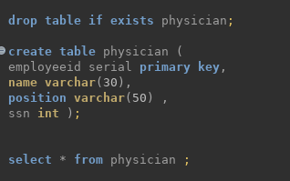

---------------------

**— ########### department ########**

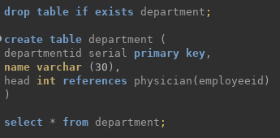

------------

**— ########### affiliated_with ########**##

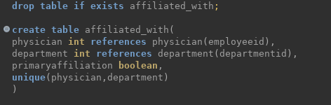

--------------------

**— ########### procedure ########**##

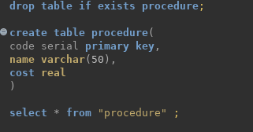

--------------

**— ########### trained_in ########**##

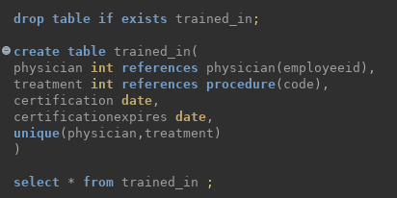

------------------

**— ########### patient ########**

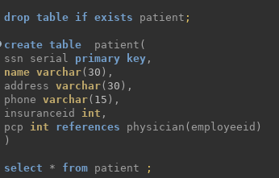

---------

**— ########### nurse ########**

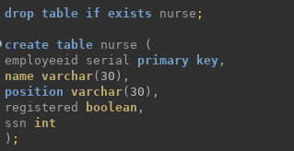

-----------------------

**— ########### appointment ########**

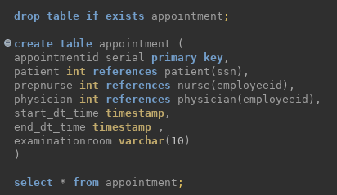

----------

**— ########### medication ########**

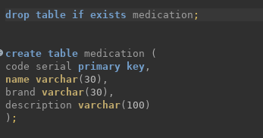

--------------

**— ########### prescribes ########**

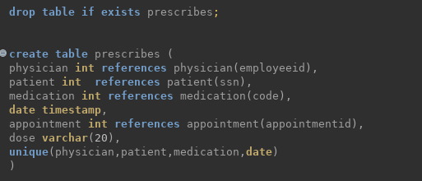

------------

**— ############# block ########**####

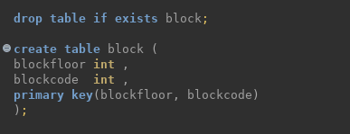

-------------------

**— ############### room ########**####

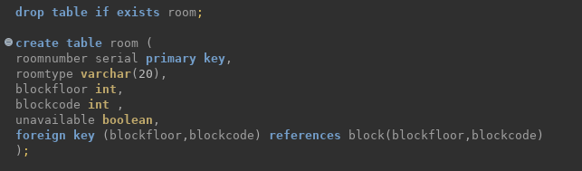

-----------------

**— ########### on_call ########**

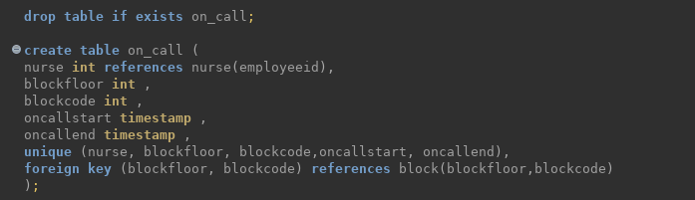

-----------------------------------

**— ########### stay ########**

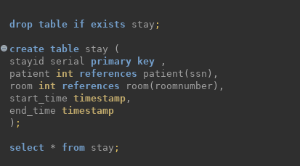

---------------------------------------

**— ########### undergoes ########**

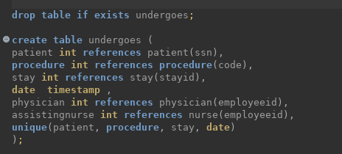

--------------------------------------

**(2). Data Load:**

Fields were included in ‘**Data of Final Assignment for Data Basics.xlsx**’ file. It contained tables in different sheets.

* First of all, I creates separate ‘**csv**’ files for each sheets with python script (saved as ‘**sheets_to_CSV.py**’ ) :

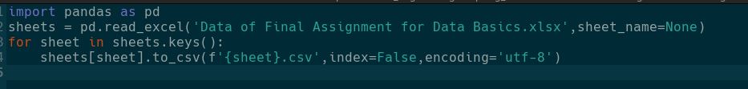

* All the Table data from each sheet were obtained in respective ‘**csv**’ format.
* The problem was integer values were changed to float values. eg. : ‘1’ was changed to ‘1.0’ in csv files. So, I replaces all “**.0**” values to empty with command:



* Now I created ‘**insert_Queries_from_CSV.sql**’ file which contains query to insert respective ‘**csv**’ data into tables.

This query file contains **\copy** command to operate from terminal.

i.e.

**\COPY TABLE_NAME FROM 'PATH_TO_CSV_FILE' DELIMITER ',' CSV HEADER;**

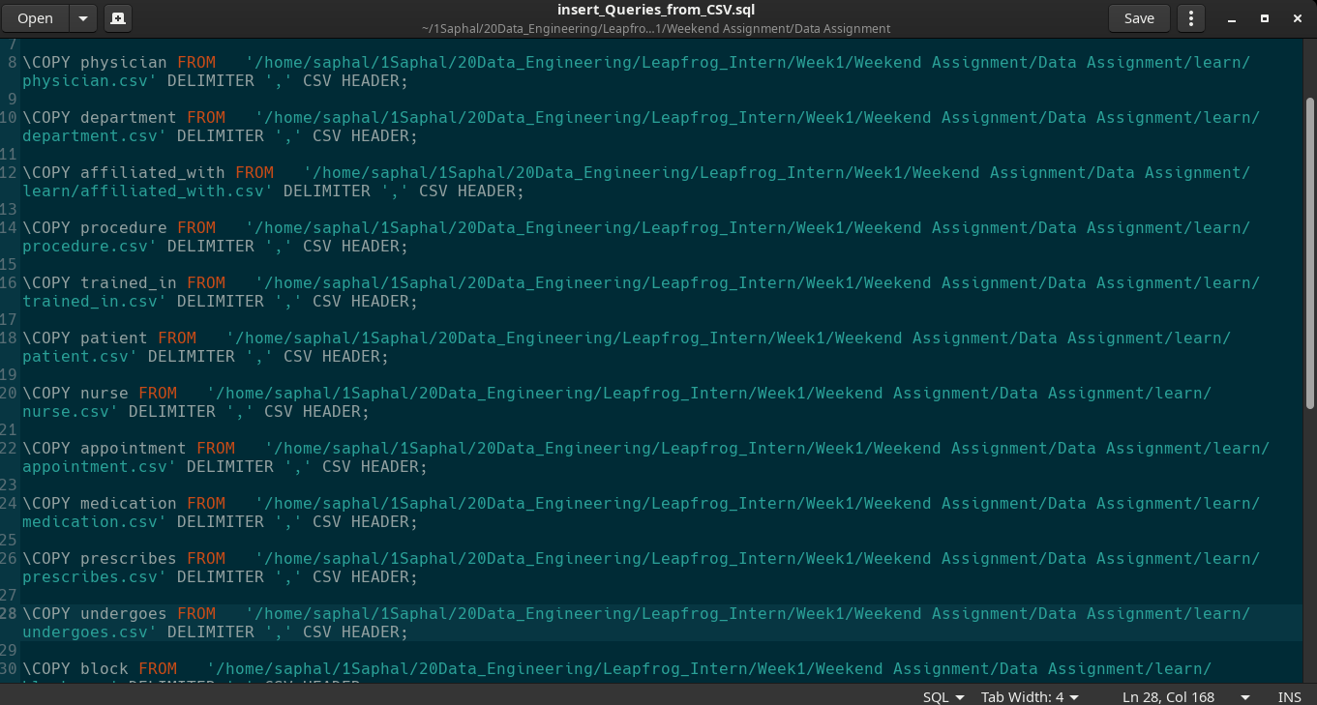

* Then I used this file to insert into tables using command :

**psql postgres -h 127.0.0.1 -d hospital -f insert_Queries_from_CSV.sql**

where **postgres**: role, **hospital**: database , **insert_Queries_from_CSV.sql**: sql file containing insert commands

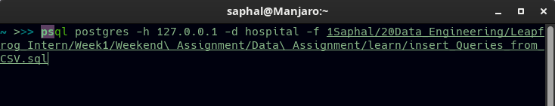

**Automated Task for future:**

* Now all these task could be run at once, so ‘**insert_data_into_tables.sh**’ bash file did all of the tasks.

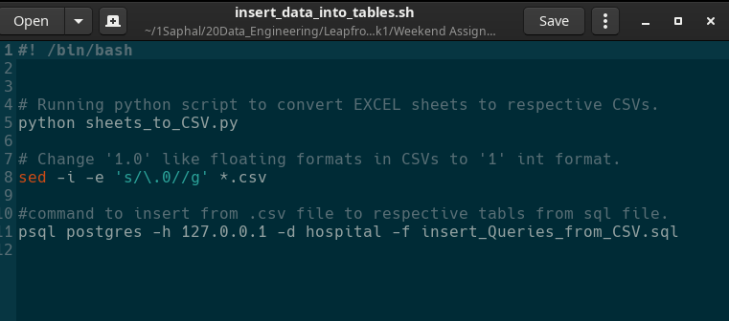

* Changed permission of this file :

**‘chmod +777 insert_data_into_tables.sh’**

* Run this file as “**./insert_data_into_tables.sh**” which does following tasks:

**1.** Convert Excel sheets to respective ‘csv’ files.

**2**. Integer values were changed to float values. eg. : ‘1’ was changed to ‘1.0’ in csv files. So, it replaces all “**.0**” values to empty.

**3.** Insert these ‘csv’ files into respective database tables.

**(2). Question Solutions :**

1. ans:

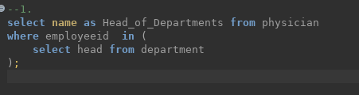

1. ans:

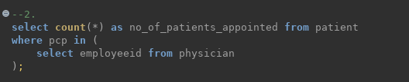

1. ans:

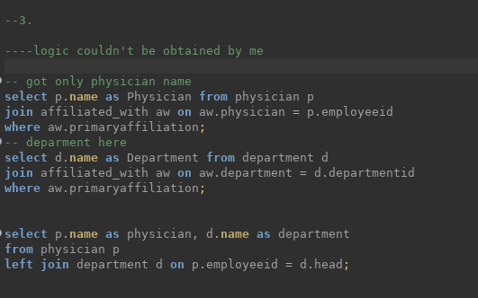

1. ans:

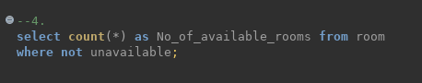

1. ans:

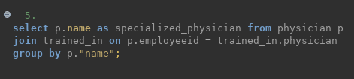

1. ans:

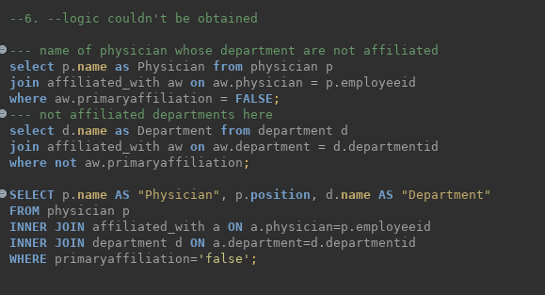

1. ans:

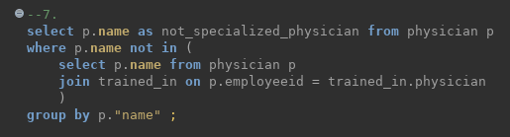

1. ans:

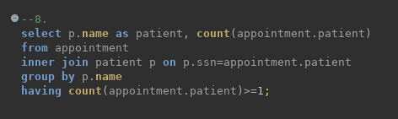

1. ans:

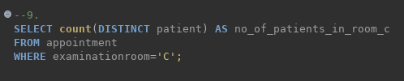

1. ans:

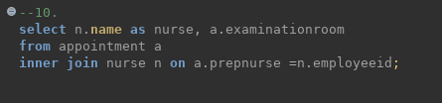

1. ans:

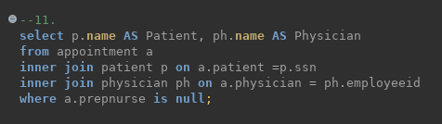

1. ans:

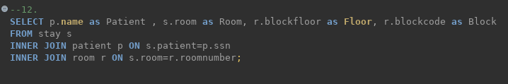

1. ans:

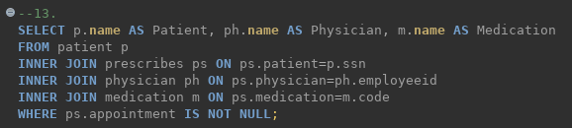

1. ans:

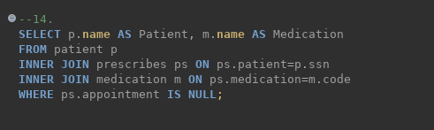

1. ans:

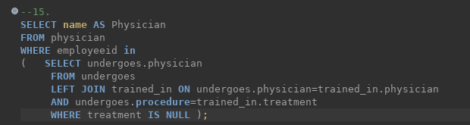

1. ans:

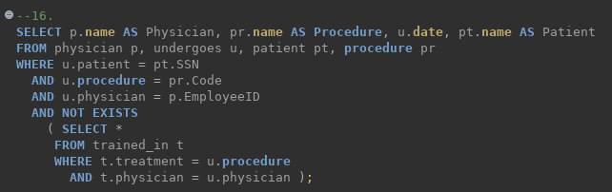

1. ans:

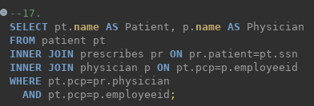

1. ans:

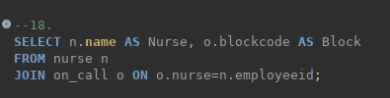

1. ans:

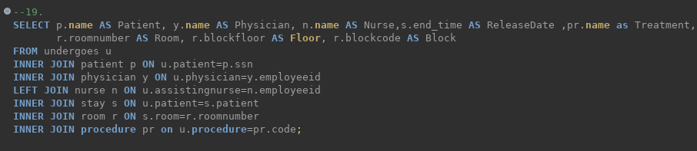

1. ans:

